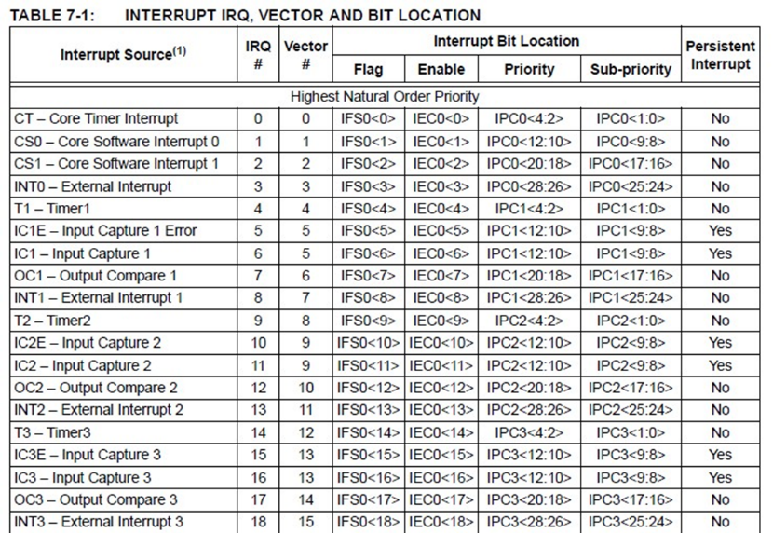**Hardware exceptions:** user or processor, external interrupts or internal timers.

**Software exceptions:** Illegal instructions, divide by 0, traps i.e. *(int*) (0x0000000)

**Exception Handling: Resets –** power on reset, external resets, watchdog, and clock monitor reset.

**Watchdog:** counts down to 0x0 and then resets processor, can’t turn off after turning on (except reset).

**Persistent interrupt** is an interrupt who’s flag does not clear until it has been serviced.

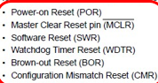**Clock Monitor:** resets when system clock frequency drops below prescribed value.

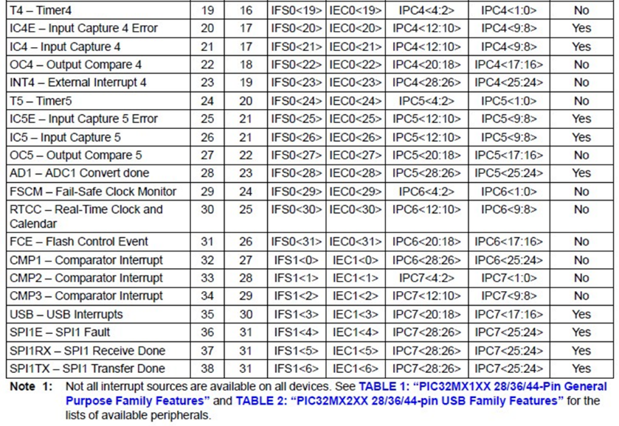**Brown-out:** supply voltage goes below threshold.

**Asynchronous Interrupt:** I/O - communication, Errors

**Synchronous Interrupts:** I/O – update periodically, Processes – switch between tasks, Timing- measure elapsed time.

**Maskable Interrupt:** enabled and disabled in software

**Non-Maskable:** enabled by software, only disabled by hardware.

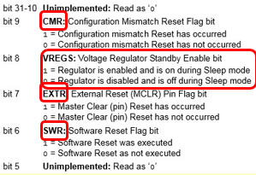

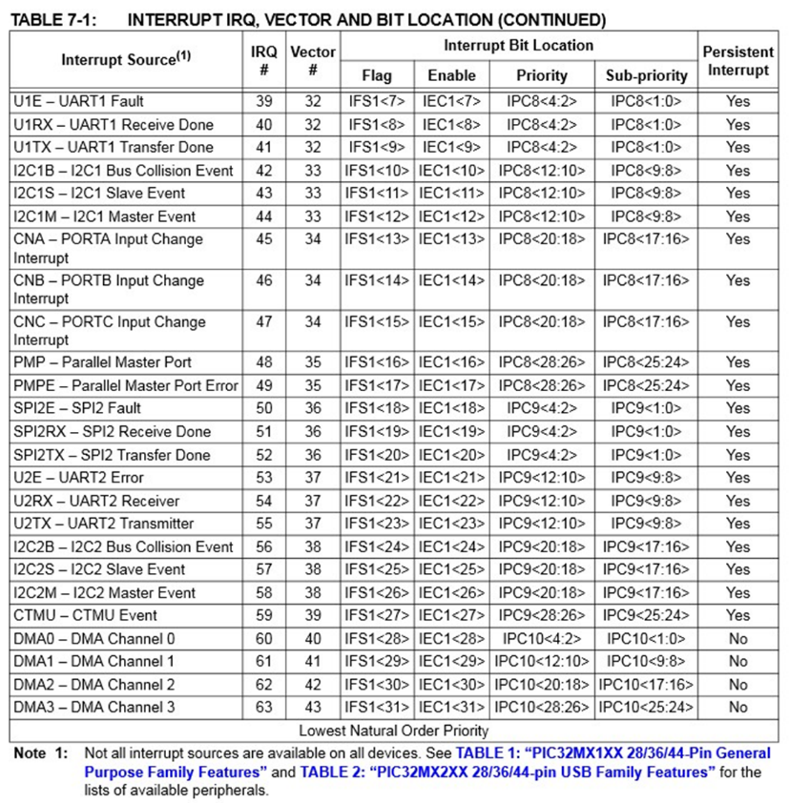

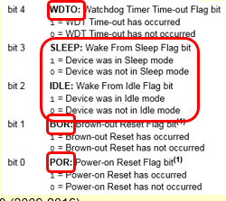

RCON:

**IP, IS:** bits 7:0 – IP00, IS00. bits 15:8 – IP01, IS01. bits 23:16 – IP02, IS02. Bits 31:24 – IP03, IS03.

**External interrupts:** INTCONbits.INTxEP – sets edge polarity (0 falling, 1 rising). INTxIE for enable

- **void __ISR(_EXTERNAL_0_VECTOR, ipl2) Int0_IRQ(void);**

- **void __attribute__( (interrupt(ipl2), vector(_EXTERNAL_0_VECTOR))) Int0_IRQ ( void );**

-

- **Input capture:** counts pulses until rising/falling edge to determine duty factors, measure Pulse width etc.

- **Output compare:** like alarm clock, create signal after predefined time has elapsed. Make PWM

- **OSCCON -**  oscillator function

- bit 21 – PBDIVRDY

- PBDIV divides SYSCLK by 1, 2, 4, 8 (default) for 00, 01, 10, 11

- **Core timer –** uses COUNT and COMPARE registers can be used to generate interrupt when COMPARE = COUNT. Interrupt 0.

- COUNT has ½ frequency of SYSCLK.

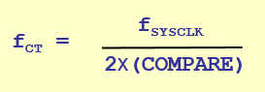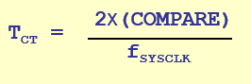

- CP0_GET_COUNT(), CPO_SET_COUNT(value), CP0_GET_COMPARE(), CP0_SET_COMPARE(val).

(PS/CBUS)*PR1

- **Timers:** PIC32 has TMR1-TMR5.

- **Type A Timer:** TMR1 sync/async 16-bit

**- Type B Timers**: TMR2- TMR5 syn 16-bit but can be

Combined, 2/3 & 4/5 to use as 32-bit

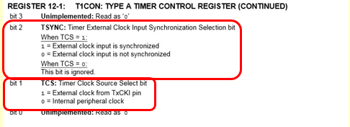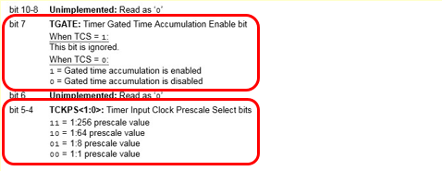Type A: T1CON

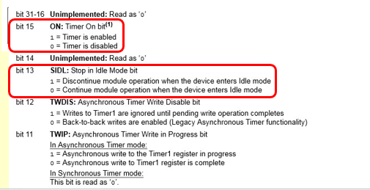**- Input Capture:** PIC32 has 5

### ADD 1 TO PRy

Type B: TxCON, x = [2,5]

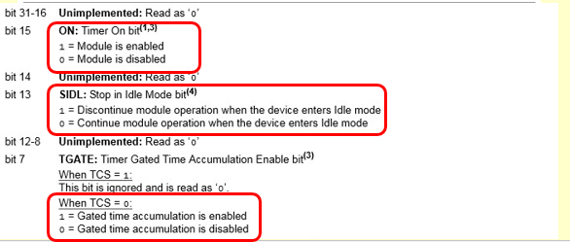

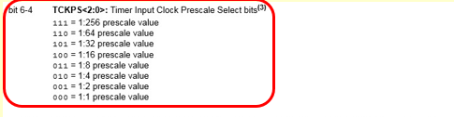

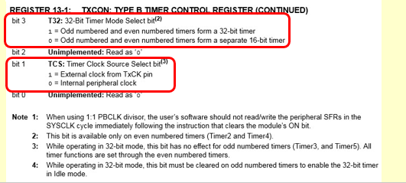

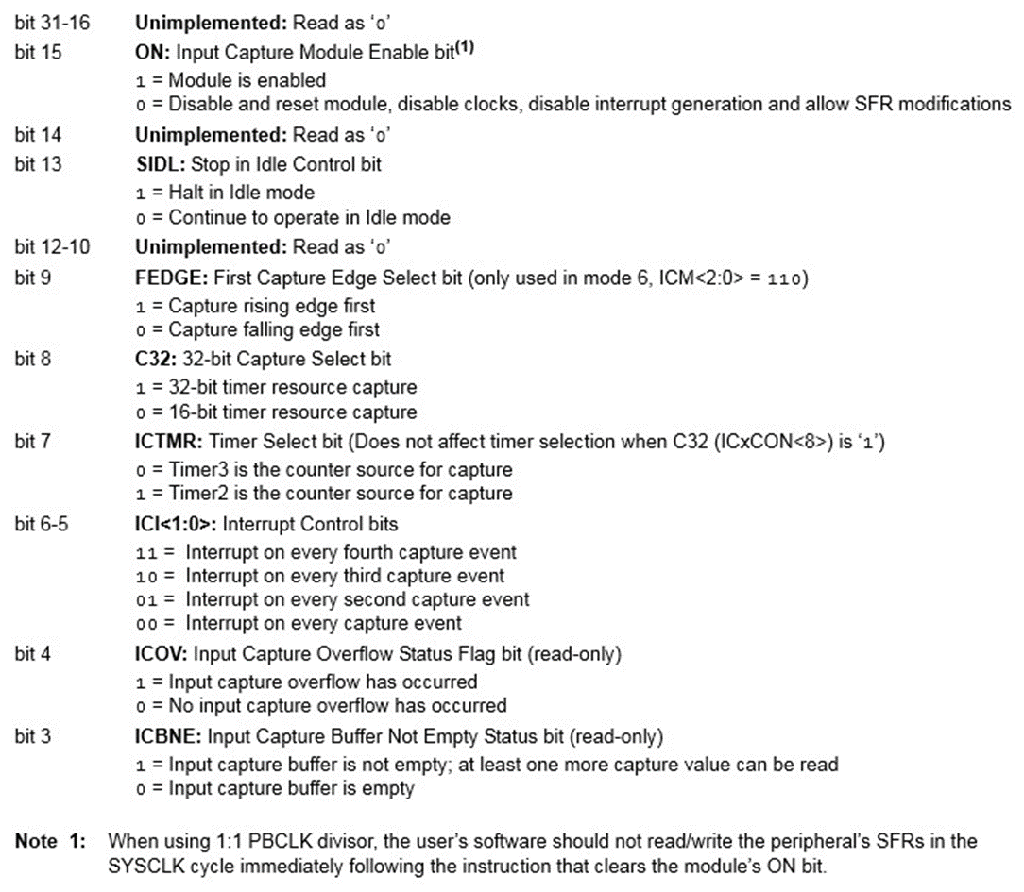 **Input Capture: ICxCON, x = [1,5]**

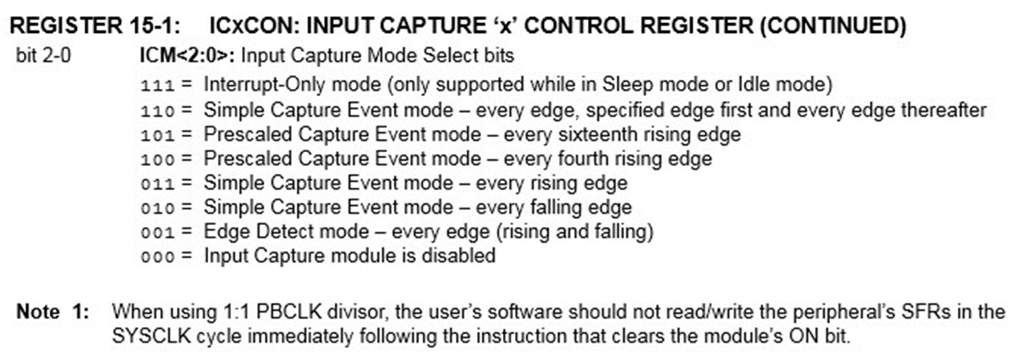

# Output compare – OCxCON, x = [1,5]

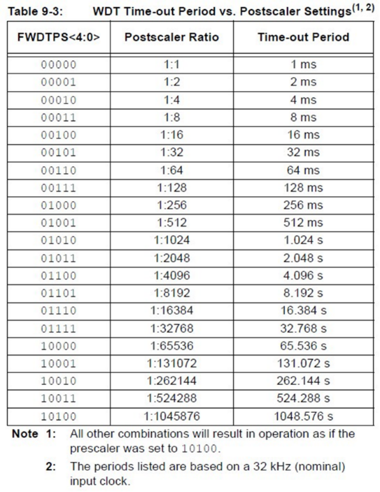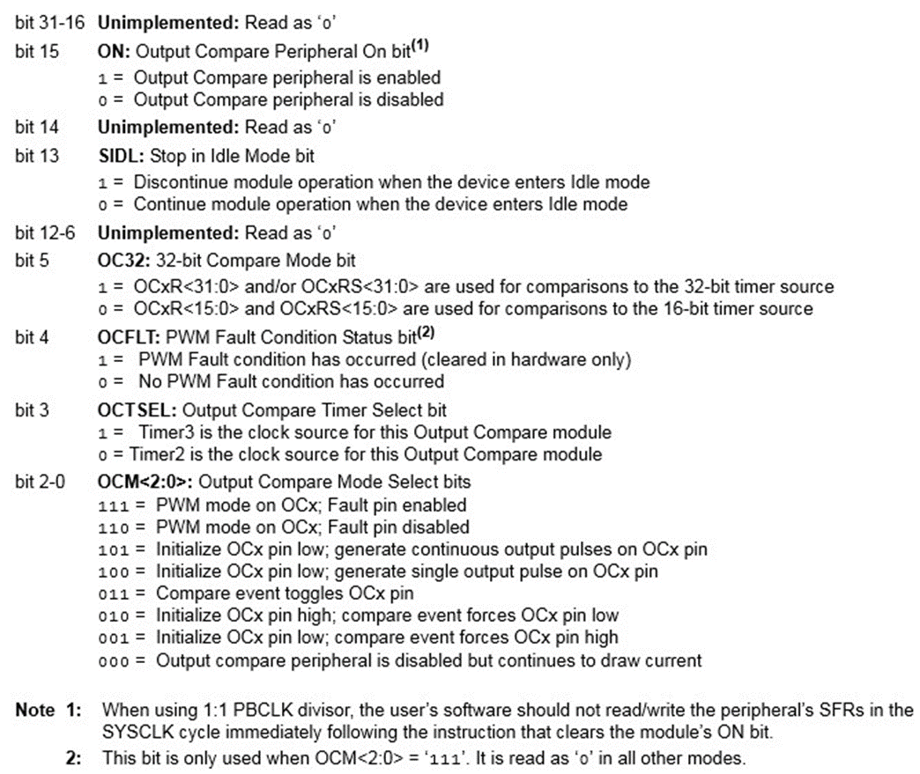- **Square Wave Calcs:** final frequency / 2 - half period on.

- **RPM:** Let N = number of “equally spaced events”

f_tmr = timer frequency

ticks = TMRx(new) – TMRx(old)

**RPM = 60 / (N * (ticks/f_tmr))**

**- Watchdog timer – STWD100**

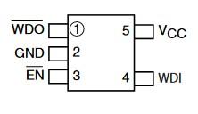

**DEVCGF1 – FWDTEN** 1 = on

## RCON --^ ------ PWM ------v

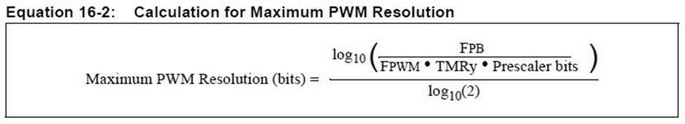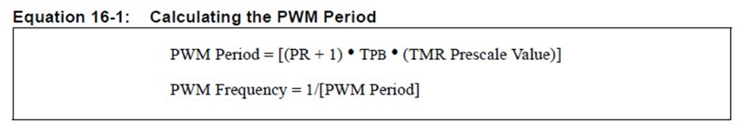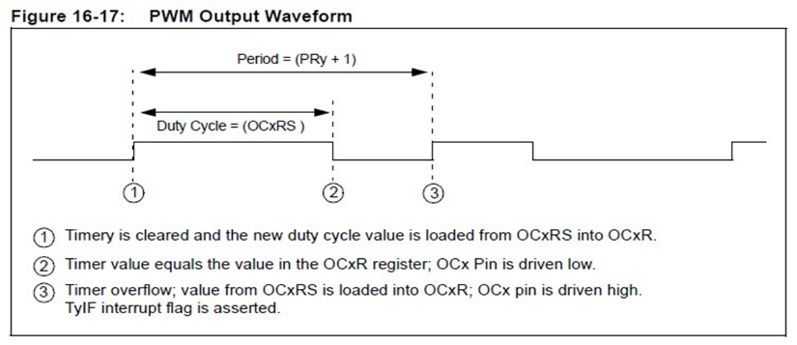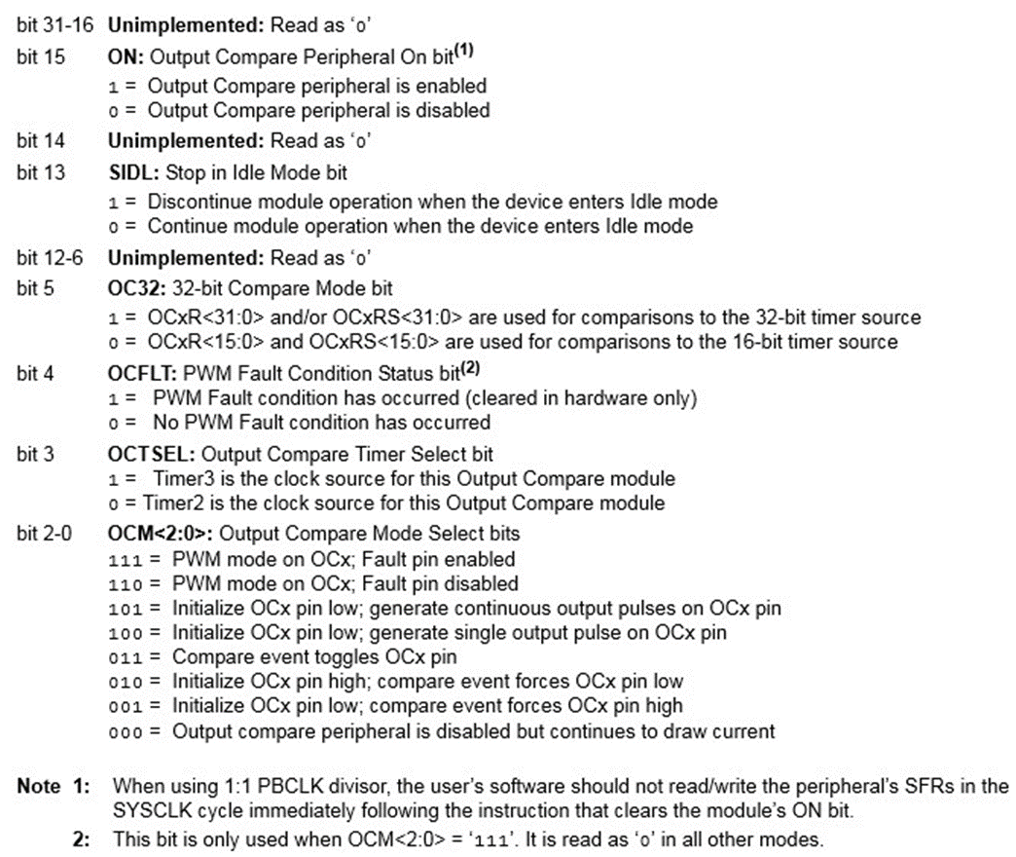**Max RES^^**  DON’T ROUND/TRUNCATE

The following is for C in Square Wave Freq questions

tSQR = 1 / fSQR (Hz → s)

Equation: tSQR=(*C* x PR x 2 x n)/fBUS

(tSQR * fBUS) / (PR x 2 x n) = C

What signal values/transitions can a PIC32MX's output compare module produce at a given pin?

**Toggle, Low Value, High Value, Low-High-Low Pulse, and Continuous Pulses**

What PIC32MX integrated peripheral works like a "Alarm Clock?"

**Output Compare**

What do you call a timer which allows an external signal to control when a timer counts and when it doesn't?

**Gated Timer**

What is register in a PIC32MX contains the timer count values? **TMR**

Which register in a PIC32MX contains the value a timer counts up to? **PR or PRx**

The diagram below shows the hardware in a PIC32MX used to perform a\[n] **Output Compare**.

Which PIC32MX timers can have an asynchronous external clock? **Timer 1**

Which PIC32MX timers cannot be used for 32 bit timers? **Timer 1**

What is the lowest value possible in a PIC32MX's TMR1 register？0

What is the highest value possible in a PIC32MX's TMR5 register? **0xFFFF, FFFF, 65535**

What PIC32MX integrated peripheral counts clock pulses until an input signal changes state? **Input Capture**

What PIC32MX integrated peripheral works like a stopwatch? **Input Capture**

When is a watchdog a necessity in an embedded system?

**A watchdog timer is a piece hardware that can be used to automatically detect software anomalies and reset the processor if any occur. Basically, A watchdog Timer is a counter that counts down to zero. However it's supposed to be reset every time the Program resets, if it isn't reset then it's assumed to be malfunctioning and the watchdog resets the program.**

What happens if a watchdog chips timer reaches zero? **It restarts the Processor.**

What peripheral chip can be used to reset a microcontroller if it cannot get out of a loop structure?

**Watchdog**

What peripheral chip can sometimes be used to reset a microcontroller if its supply voltage falls to an invalid value? **Watchdog**

What does a programmer have to do to prevent a Watchdog from timing out and resetting a processor?

**It will have to be 'kicked' regularly, i.e. communicated with, once every given period.**

What type of chip does the diagram shown below? **Watchdog Timer**

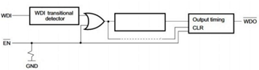

What is the purpose of the WDI pin? **watchdog input, likewise WDO is watchdog output**

Equation: Instructions = CSYSCLK x TTIMEOUT

Since all/most of these equations ask for the answer in the thousands, just use this:

Instructions = CSYSCLK x TTIMEOUT x 10-3

Round your number for instructions

WDTCONbits.WDTPS = X;

Equation: Max PWM Resolution Bits = log2( PRx)

For Vrms of a PWM, use…

Formula: √(OC1R/(PR1 + 1)) x VPWM

The following is for PWM Freq

This requires 2 different pages of the datasheet.

A =  PBDIV divider

B = TCKPS determined prescale value

Equation: TPWM = (PR + 1) x (A / fSYSCLK) x (B)

These questions are asking for the *frequency,* so you need to convert the output that is in time to that by doing 1/Tpwm

For OSCCON…

bit 20-19 **PBDIV<1:0>:** Peripheral Bus Clock (PBCLK) Divisor bits

11 = PBCLK is SYSCLK divided by 8 (default)

10 = PBCLK is SYSCLK divided by 4

01 = PBCLK is SYSCLK divided by 2

00 = PBCLK is SYSCLK divided by 1

What does PWM stand for?

Pulse Width Modulation

What property/characteristic of a microcontroller allows a PWM to be useful?

PWM allows a microcontroller to interface with many analog components. The microcontroller, being a digital device, only outputs a binary result, so PWM allows some components to be "tricked" by sending pulses and a specific frequency.

Give an example of a practical use of a PWM waveform.

Controlling a motor’s speed

How do you get a 100% duty factor using the PWM of a PIC32MX?

By having OCxR greater than PRy

What does “Modulation” mean in PWM?

A technique used in communication systems for coding the height of the signal. So it controls the amplitude of the signals.

What is the maximum number of duty factors that a 16-bit Output Compare module on a PIC32MX can produce? **65536**

What is the maximum number of PWM that can be running at any given time on a PIC32MX? **5**

What is the maximum number of different PWM periods that a 32-bit Output Compare module can produce on a PIC32MX? **4294967296**

How do you get a 100% duty factor using the PWM of a PIC32MX?  
 **When OCxR is loaded with a 0x0000, the OCx pin will remain low  giving a 0% duty cycle.**

What is the maximum number of duty factors that a 32-bit Output Compare module on a PIC32MX can produce? **2^32**

What is the purpose/use of PWM “fault protection?”

**To prevent a steady high from being left on the PWM control line in case of a reset/power up, etc.**

What is the maximum number of PWM that can be running at any given time on a PIC32MX? **5**

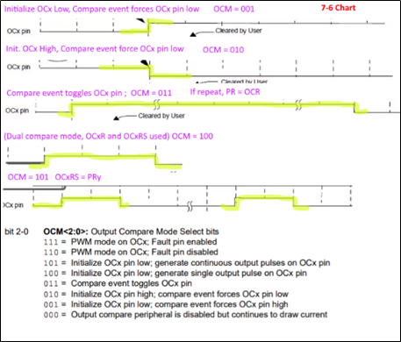What is the maximum number of duty factors that a 16-bit Output Compare module on a PIC32MX can produce? **2^16 = 65536**

OCM command depends on graph below (from pg. 164)

PR2 is the highest value the TMRy value gets to before resetting to 0

OC1R is the value where the rising edge starts at (see graphic below)

OC1RS is the value of the *falling* edge of the first pulse. This only applies to diagrams that have pulses in them. If they don’t, this is just X.